**Player Spawner Module**

This module is related to player spawning during gameplay

**Versions Used:**

* Unity 2019.4.14 f1 and above

**Architecture:**

* Scriptable Object Architecture

**Scripts:**

* 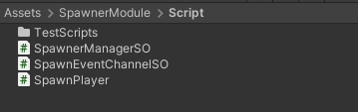SpawnerManagerSO.cs
* SpawnEventChannelSO.cs
* SpawnPlayer.cs

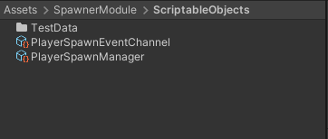**Channels (Scriptable Objects):**

* PlayerSpawnEventChannel

**Manager (Scriptable Object):**

* PlayerSpawnManager

**How It Works:**

PlayerSpawnEventChannel.cs event is called from SpawnPlayer.cs. PlayerSpawnManager.cs is an scriptable object it will subscribe different PlayerSpawnEventChannel.cs events on scene start. When Event will be called the desired object will be spawned.

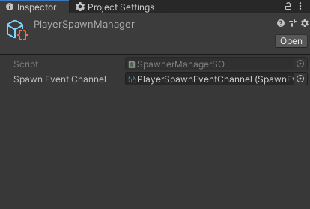PlayerSpawnManager.cs should have reference to all spawning channels.

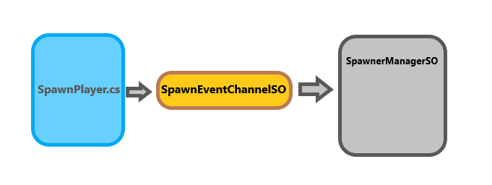

**How To Use:**

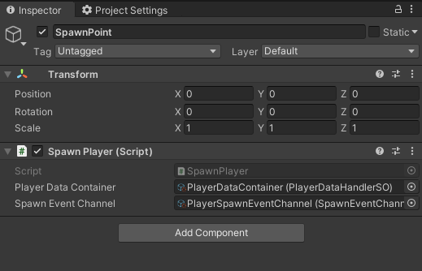 SpawnPlayer.cs is placed in hierarchy on desired spawning point. It would be

provided with player data

container from where data of

current selected player will

retrived and will also take

reference to spawn event channel.

To instantiate a simple object we have to call ShootSpawnEvent function with arguments and it will generate a gameobject in the scene.

**That’s All**

Any **Questions** or **Feedback**?

Feel free to contact **developer** :D

!!muhammadumar@theknights.com.pk!!